VPN
崔浩为
- ａｂ
配置前
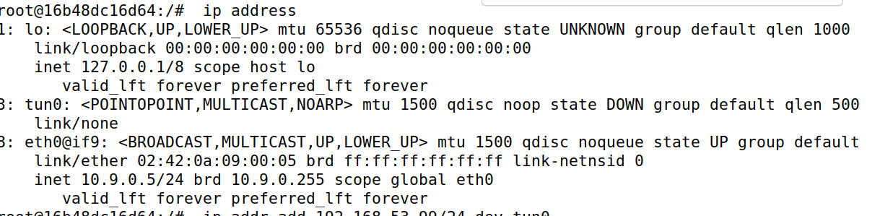
运行
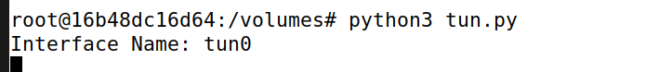
配置
分配结果
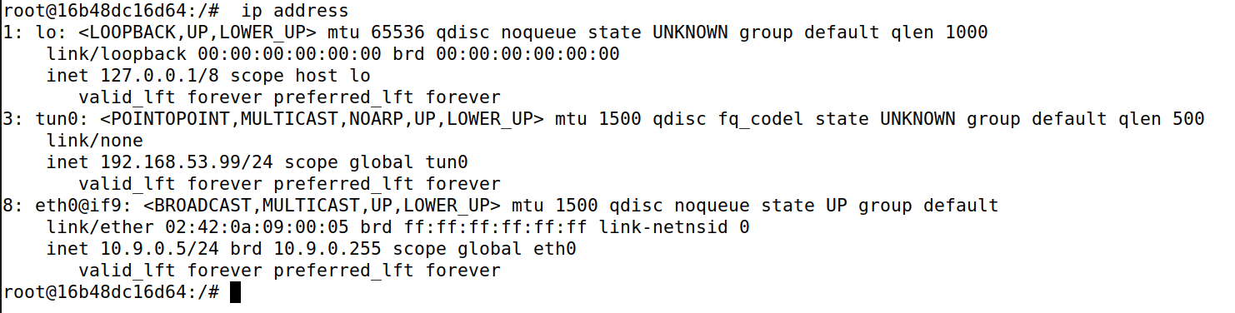

２．Ｃ
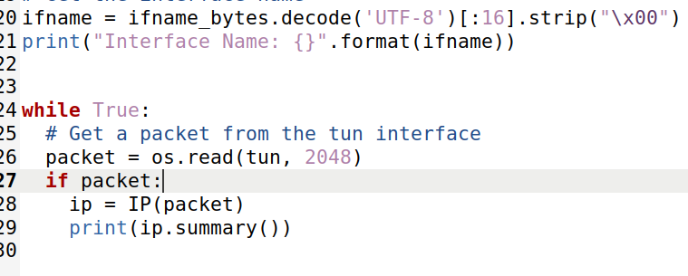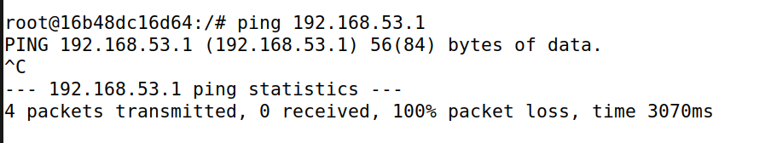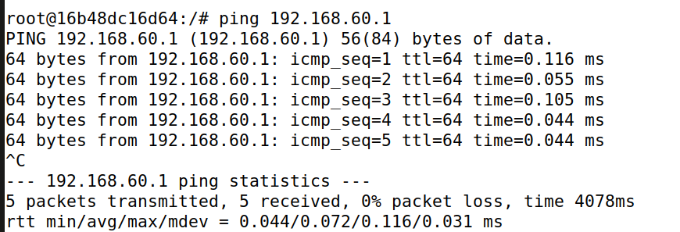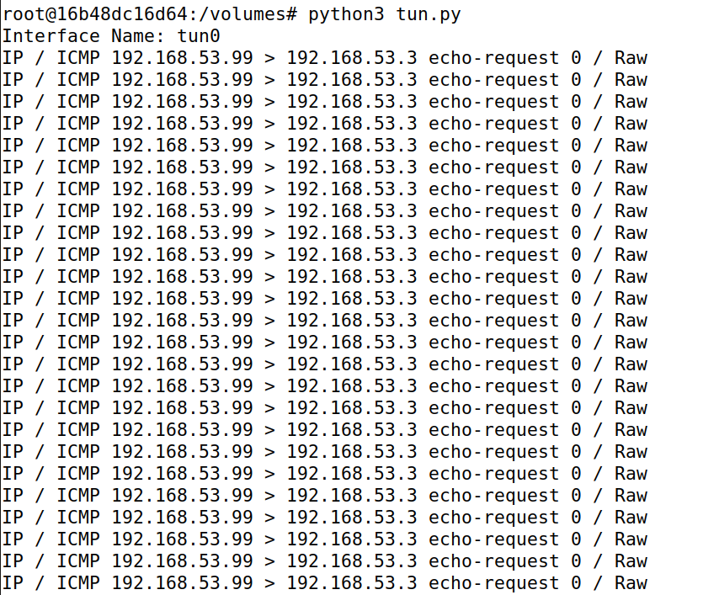

d
#!/usr/bin/env python3

import fcntl
import struct
import os
import time
from scapy.all import *

TUNSETIFF = 0x400454ca
IFF_TUN = 0x0001
IFF_TAP = 0x0002
IFF_NO_PI = 0x1000

# Create the tun interface
tun = os.open("/dev/net/tun", os.O_RDWR)
ifr = struct.pack('16sH', b'tun%d', IFF_TUN | IFF_NO_PI)
ifname_bytes = fcntl.ioctl(tun, TUNSETIFF, ifr)

# Get the interface name
ifname = ifname_bytes.decode('UTF-8')[:16].strip("\x00")
print("Interface Name: {}".format(ifname))

os.system("ip addr add 192.168.53.99/24 dev {}".format(ifname))
os.system("ip link set dev {} up".format(ifname))

while True:
# Get a packet from the tun interface
packet = os.read(tun, 2048)
if True:
pkt = IP(packet)
print(pkt.summary())

if ICMP in pkt:
newip = IP(src=pkt[IP].dst, dst=pkt[IP].src, ihl=pkt[IP].ihl)
newip.ttl = 216
newicmp =ICMP(type=0, id=pkt[ICMP].id,seq=pkt[ICMP].seq)
if pkt.haslayer(Raw):
data = pkt[Raw].load
newpkt = newip/newicmp/data
else:
newpkt = newip/newicmp
os.write(tun,bytes(newpkt))

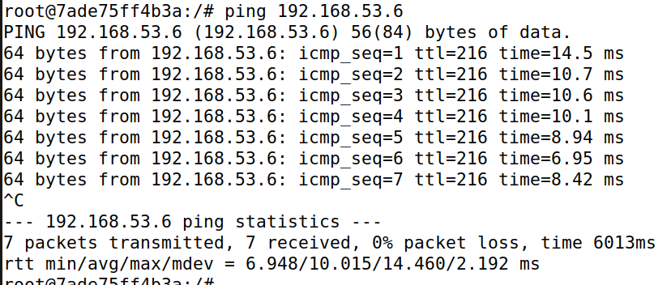
ping通

Task 3
服务器端
#!/usr/bin/env python3

import fcntl
import struct
import os
import time
from scapy.all import *

TUNSETIFF = 0x400454ca
IFF_TUN = 0x0001
IFF_TAP = 0x0002
IFF_NO_PI = 0x1000

# Create the tun interface
tun = os.open("/dev/net/tun", os.O_RDWR)
ifr = struct.pack('16sH', b'tun%d', IFF_TUN | IFF_NO_PI)
ifname_bytes = fcntl.ioctl(tun, TUNSETIFF, ifr)

# Get the interface name
ifname = ifname_bytes.decode('UTF-8')[:16].strip("\x00")
print("Interface Name: {}".format(ifname))
os.system("ip addr add 192.168.53.11/24 dev {}".format(ifname))
os.system("ip link set dev {} up".format(ifname))

server = socket.socket(socket.AF_INET, socket.SOCK_DGRAM)
SERVER_IP="0.0.0.0"
SERVER_PORT=9090
server.bind((SERVER_IP,SERVER_PORT))

while True:
data,(ip,port) = server.recvfrom(2048)
print("{}:{}-->{}:{}".format(ip,port,SERVER_IP,SERVER_PORT))
pkt=IP(data)
print("Inside : {}:{}".format(pkt.src,pkt.dst))
os.write(tun,data)

用户端
#!/usr/bin/env python3

import fcntl
import struct
import os
import time
from scapy.all import *

TUNSETIFF = 0x400454ca
IFF_TUN = 0x0001
IFF_TAP = 0x0002
IFF_NO_PI = 0x1000

# Create the tun interface
tun = os.open("/dev/net/tun", os.O_RDWR)
ifr = struct.pack('16sH', b'tun%d', IFF_TUN | IFF_NO_PI)
ifname_bytes = fcntl.ioctl(tun, TUNSETIFF, ifr)

# Get the interface name
ifname = ifname_bytes.decode('UTF-8')[:16].strip("\x00")
print("Interface Name: {}".format(ifname))

os.system("ip addr add 192.168.53.99/24 dev {}".format(ifname))
os.system("ip link set dev {} up".format(ifname))
os.system("ip addr add 192.168.60.0/24 dev {}".format(ifname))

sock = socket.socket(socket.AF_INET, socket.SOCK_DGRAM)
SERVER_IP="10.9.0.11"
SERVER_PORT=9090

while True:
# Get a packet from the tun interface
packet = os.read(tun, 2048)
if packet:
pkt = IP(packet)
print(pkt.summary())
sock.sendto(packet, (SERVER_IP, SERVER_PORT))

通过隧道发送成功
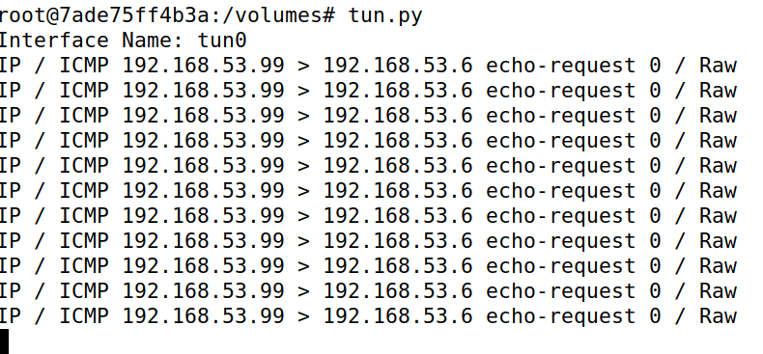

剩余task4-task6内容
客户端
#!/usr/bin/env python3

import fcntl
import struct
import os
import time
from scapy.all import *

TUNSETIFF = 0x400454ca
IFF_TUN = 0x0001
IFF_TAP = 0x0002
IFF_NO_PI = 0x1000

# Create the tun interface
tun = os.open("/dev/net/tun", os.O_RDWR)
ifr = struct.pack('16sH', b'tun%d', IFF_TUN | IFF_NO_PI)
ifname_bytes = fcntl.ioctl(tun, TUNSETIFF, ifr)

# Get the interface name
ifname = ifname_bytes.decode('UTF-8')[:16].strip("\x00")
print("Interface Name: {}".format(ifname))

os.system("ip addr add 192.168.53.99/24 dev {}".format(ifname))
os.system("ip link set dev {} up".format(ifname))
os.system("ip addr add 192.168.60.0/24 dev {}".format(ifname))

sock = socket.socket(socket.AF_INET, socket.SOCK_DGRAM)
SERVER_IP="10.9.0.11"
SERVER_PORT=9090
fds=[sock,tun]
while True:
ready,_,_=select.select(fds,[],[])
for fd in ready:
if fd is sock:
data,(ip,port)=sock.recvfrom(2048)
pkt=IP(data)
print("From socket : {} --> {}".format(pkt.src,pkt.dst))
os.write(tun,data)

if fd is tun:
packet = os.read(tun,2048)
if packet:
pkt=IP(packet)
print(pkt.summary())
sock.sendto(packet,(SERVER_IP,SERVER_PORT))

服务器
#!/usr/bin/env python3

import fcntl
import struct
import os
import time
from scapy.all import *

TUNSETIFF = 0x400454ca
IFF_TUN = 0x0001
IFF_TAP = 0x0002
IFF_NO_PI = 0x1000

# Create the tun interface
tun = os.open("/dev/net/tun", os.O_RDWR)
ifr = struct.pack('16sH', b'tun%d', IFF_TUN | IFF_NO_PI)
ifname_bytes = fcntl.ioctl(tun, TUNSETIFF, ifr)

# Get the interface name
ifname = ifname_bytes.decode('UTF-8')[:16].strip("\x00")
print("Interface Name: {}".format(ifname))
os.system("ip addr add 192.168.53.11/24 dev {}".format(ifname))
os.system("ip link set dev {} up".format(ifname))

sock = socket.socket(socket.AF_INET, socket.SOCK_DGRAM)
SERVER_IP="0.0.0.0"
SERVER_PORT=9090
ip = "10.9.0.5"
port = 10000
sock.bind((SERVER_IP,SERVER_PORT))
fds=[sock,tun]
while True:
ready,_,_=select.select(fds,[],[])
for fd in ready:
if fd is sock:
print("sock...")
data,(ip,port)=sock.recvfrom(2048)
print("{}:{}-->{}:{}".format(ip,port,SERVER_IP,SERVER_PORT))
pkt=IP(data)
print("Inside : {}:{}".format(pkt.src,pkt.dst))
os.write(tun,data)
if fd is tun:
print("tun...")
packet = os.read(tun,2048)
pkt=IP(packet)
print("Return : {}:{}".format(pkt.src,pkt.dst))
sock.sendto(packet,(ip,port))
